Winter 2017 Play Group Registration

Coalition for Children, Falmouth’s CFCE Grant ~ Session Dates are January 9 – March 25

Parent Name _________________________________________________

Child(ren)’s name and ages________________________________________

Street Address _______________________________________________

Town _______________________________________________________

Phone ______________________________________________________

Email _______________________________________________________

For more information please visit

[www.thecoalitionforchildren.org](http://www.thecoalitionforchildren.org)

or call 508.548.0151 x172

Please indicate which playgroup best suits your needs; use #1 for your first preference, #2 for your second. Please list all children that will be attending with you. You may leave your completed form in the box in the Children’s room of the Falmouth Public Library or bring it to our office in the Falmouth School Administration Building.

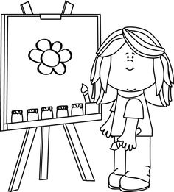

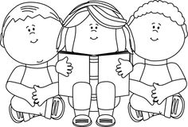

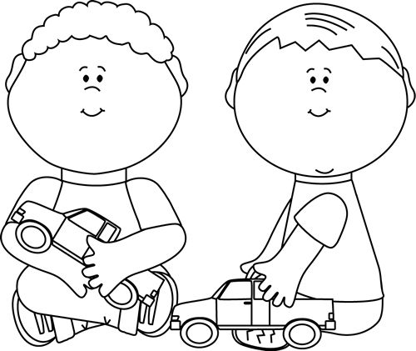

**Monday**

9:30 Mixed Age Playgroup (Closed group) @ Carriage House, Falmouth

**Tuesday**

9:45 Intergenerational Music & Movement (Registered Class for ages 2.5 and up) @ JML Care Center _____

12:15 Pre-K Lunch Bunch ( Registered Class for ages 3 and up)

@ Falmouth School Administration Building _____

**Wednesday**

9:00 Mixed Age Playgroup (Drop In) @ Falmouth School Administration Building

10:45 Read and Rhyme Story time (Drop In) @ East Falmouth Public Library

**Thursday**

9:45 Lap babies (Drop In) @ Falmouth Public Library

10:30 Preschool Story time (Drop In) @ Falmouth Public Library

**Friday**

10 Tots & Tales (Drop In) @ Falmouth Public Library

11:00 Music & Movement @ (Registered Class for ages 2.5 and up) Falmouth Public Library _____

All of our groups are FREE!!

**The Coalition for Children is funded by the**

**Massachusetts Department of Early Education and Care.**

**Please note – all groups subject to MA state funding cuts.**

